TAINTED MONEY

Timmy didn’t want to put his money in the offering plate Sunday morning, so his mother decided to use some hurried creative reasoning with him.
“You don’t want that money, honey,” she whispered in his ear. “Quick! Drop it in the plate. It’s tainted!”
Horrified, the little boy obeyed.
After a few seconds he whispered, “But, mommy, why was the money tainted? Was it dirty?
“Oh, no dear,” she replied. “It’s not really dirty. It just ‘taint yours, and it ‘taint mine,” she replied. “It’s God’s.”


BASEBALL IN HEAVEN
Have you heard about the first baseball game in the Bible?
In the big inning. Eve stole first; Adam stole second. Cain struck out Abel. The Giants and the Angels were rained out.


DUNKING TANK
This summer’s church carnival included a dunking tank, where softball throwers with good aim could make a big splash with
the pastor. The tank proved a popular attraction, but things really took off when the pastor put a sign above himself that read, “Goliath.”
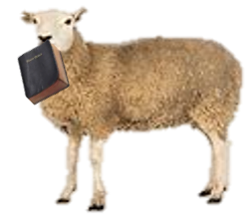

A SHEEPISH RECOVERY
A devout old shepherd lost his favorite Bible while he was out looking for a wayward lamb. Three weeks later, a sheep walked
up to him carrying the Bible in its mouth. The shepherd couldn’t believe his eyes. He took the precious book out of the sheep’s mouth, raised his eyes heavenward and exclaimed, “It’s a miracle!”
“Not really,” said the sheep. “Your name’s written inside the cover.”


First Baptist Church Strathroy
Where Christ is cherished, family is loved and everyone is family!

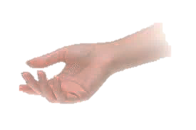


GETTING CONNECTED

Publication of…
First Baptist Church Strathroy
Strathroy, Ontario N7G 1T5 519-245-0291 / 519-317-8659 (cell)
firstbaptistchurchstrathroy@gmail.com
www.FirstBaptistChurchStrathroy.ca, Edited by Pastor Dave Adams
Autumn Blessings
Autumn brings to the soul relief,
as hot summer days slip to an end
God sent the season for weary hearts
to restore, repair and mend.

Unlike the Autumn trees,
that shed their changing leaves
God sent the season for failing hearts
to adhere, embrace and cleave.

Just as with the Autumn winds,
there comes a refreshing rain
God sent the season for fraying hearts
to increase, grow and gain.

The Autumn sun is slow to climb,
And dips much earlier into the night
God sent the season for sleepy hearts
to rise, shine and awake His Light.

God gave to us the Autumn season,
so we could have a respite and rest
for it is the season for our beset souls
to see how much we are truly blessed.
By Deborah Ann Belka

September 2026
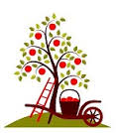

“Show your steadfast love of those who seek refuge...keep [them] as the apple of your eye; hide [them] in the shadow of your wings” (Psalm 17)

What’s inside…
- Learning Takes Time
- Test your Biblical trivia
- Something to Talk About
- Mark Your Calendar
- Tainted Money
- Baseball in Heaven
- Dunking Tank
- A Sheepish Recovery
- This always happens…

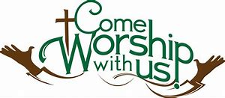
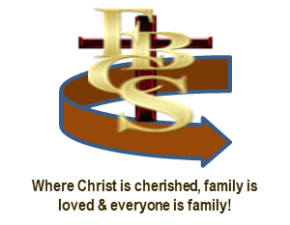

Sundays 11 a.m. Services
[September 6th at 10:30 a.m.]
20 Centre Street W., Strathroy, Ontario
Thot: “The more we dedicate ourselves to living according to God's will, the more God will empower us to do His will.”
~ Aleksandar Valkanov, Pastor in Pazardjik, Bulgaria

LEARNING TAKES TIME
Luke comes home from his first day of school, and his mother asks, “What did you learn today?”
“Evidently, not enough,” Luke replies. “They said I have to go back tomorrow.”

H20

The science teacher asked Donald, “what is the chemical formula for water?”
Donald quickly recited, “H-I-J-K-L-M-N-O”

The exasperated teacher then asked, “What are you talking about?”

Donald explained, “Well, yesterday you said it was H to O.
Something to Think About

"Brothers and sisters, we have confidence to enter…by the new and living way that He opened for us… ~ Hebrews 10:19, 20.

Ever find yourself stumbling along a path that isn’t taking you where you want to go, or looking back at the path that has led you nowhere? O how you long for something different! It’s true that doing the same thing over and over and expecting a different result is a sign of insanity – and it’s enough to drive you over the edge. But what can you do?
It begins with a change of focus. Mary Pickford is quoted as saying, “You may have a fresh start any moment you choose, for this thing we call ‘failure’ is not falling down, but staying down”. An example of this is found in the life story of Annie Johnson of Arkansas, a single mom with two toddlers in the early 20th century. In addition to her disastrous marriage, she was a negro with limited career choices. But Annie decided to take a new road. She had “looked up the way I was going and back the way I had come and since I wasn’t satisfied, I decided to step off the road and cut me a new path”.
Her thought was to prepare meals for the workers at the two factories. And so, the next day she left her house carrying an iron brazier and coals for a fire. Just before lunch time, she arrived at an empty lot behind the cotton gin. Soon savory arose carrying the scent of her homemade deep fried meat pies which she sold at 5 cents each wrapped in newspapers which soaked up the grease. What was left she sold at 3 cents to the cotton gin workers. The next day she reversed the order.
She eventually built a stall midway between the two factories and let the men come to her. Eventually the stall became a store selling cheese, meal, syrup, canned goods, fresh fruit, soft drinks, coal, oil and of course meat pies. Annie had indeed stepped from the road and cut herself a brand-new path. Each of us too has the opportunity, and the responsibility, to assess the road that lays ahead, and those over which we’ve traveled.
Many times, we may find that the road we face and want to move on from isn’t just a physical place but a spiritual battle. Here too, we must decide what path we will follow. God promises that we can come to Him – all who are heavy laden and we’ll find rest in Jesus (Matthew 11:28). That new place gives us new opportunities to shape our lives according to God’s will rather than our own, and rather than pursuing the way of the world. The apostle Paul writes, “Anyone who belongs to Christ has become a new person. The old life is gone; a new life has begun” (2 Corinthians 5:17).
When our future looks bleak, and the past is uninviting, we need to build resolve to step off the road into a new direction. When we step into a new life in Christ, we do just that. We’re made new in Christ, invited to a new way of thinking, walking a new pathway. Rather than following the pursuits of this world, our pursuit is of God’s kingdom.
Yes, we will find we still carry some baggage, and it will take work and finding others to come alongside of us for encouragement, but we will find confidence as we enter “by the new and living way that He opened for us” (Hebrews 10:20).
Mark Your Calendar!
September 6th – Communion Sunday
September 12th – Men’s Breakfast (8:30 a.m.)
September 13th – Fall Kick Off
Special guests – Wayne & Wendy Lockyer
Wednesdays
Weekly Prayer (FBCS Prayer Room) 1:30 pm
Fall Study resumes…
Monday September 21st 7 p.m.
– When a Nation will not listen

Messages this month...
Biblical Truths We Stand On

It begins by accepting the author and perfector of our faith, the Lord Jesus Christ, as our Saviour. He remains the only “way, truth and life” (John 14:6) for pursuing a new path that fulfills our need. Only when we see the
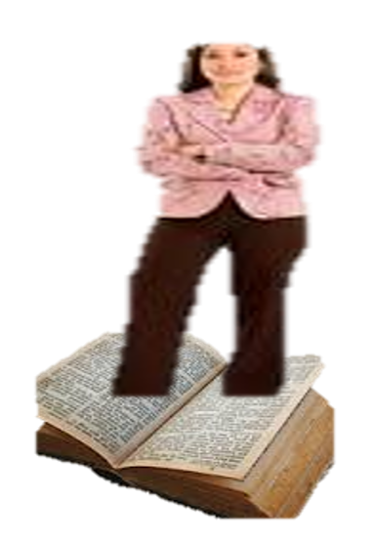
risen Jesus; only as we see beyond the world that ends in death; can we, with eyes wide open, look along that new pathway that leads to eternal life as Jesus works His perfection through us.
What a wonderful new road awaits all who are willing to turn to Christ, confess their need for a new direction in their life and accept His offer of forgiveness for sin, His grace to live as overcomers, discovering the magnificent gift that awaits them. This is the promise that I leave with you today, that if you have said no to self and yes to Jesus; then God has said, “He made Him who knew no sin to be sin on [your] behalf, so that [you] might become the righteousness of God in Him” to include Him in your life.
Are you stumbling along a weary pathway that is taking you nowhere? I invite you to simply call out, “Jesus, I accept you as my Saviour. I confess that I’m a sinner and ask to receive your grace that only God can give. I have decided to walk a new pathway – not of this world’s way, but a path holding hands with you, Jesus, as I come in your precious name. Amen.”

